***Ultrasound Distance Detection on Moving Objects – A Research Project.***

***By Kieran Small – 10699216***

***Supervisor – Professor Adrian Ambrose***

Summary/Abstract

Acknowledgements

Contents

Introduction

Design Brief

Testing Methods

Project Management

Conclusions

References

Bibliography

Appendices: Project, Proposal, Work, Plan, Costings Etc Etc

# *ABSTRACT*

In this Project/report, the limitations and challenges faced in using ultrasound to measure distance are investigated. The system implemented measures the time between a signal sent from a microcontroller which allows a 50kHz sinewave pulse to be transmitted by one transducer, and an input signal which is the received pulse after it has bounced off of the object whose distance it was measuring and has been rectified. The distance measured is then calculated by the equation *Distance = Speed* Time* with the speed equal to roughly 343m/s at room temperature. The ambient temperature is measured and the speed is changed accordingly to add greater precision. Among multiple challenges faced, foremost was setting a reasonable threshold limit to distinguish between noise and the start of the received pulse and a delay between the measured and theoretical time was subtracted from the calculation to give a more accurate measurement because of this.

KEYWORDS: ULTRASOUND, DISTANCE MEASUREMENT

# *INTRODUCTION*

This project aims to accurately measure objects whilst they are moving using the medium of ultrasound to do so. The main point of this is not the application itself, i.e. distance measurement, since there are many devices which can do this, using infra-red and lidar, and although ultrasound can have its advantages compared to these, such as how it is not impacted by light and so can be used just as successfully during the day or night, ultrasound typically works over shorter distances and can be disturbed by adverse weather conditions if used outside (rain drops can cause random scattering of the signal along with changing its speed of propagation an uncalculatable amount when moving through the water) and can impeded by large changes in temperature (the speed of sound ranges between 331.5m/s at 0 degrees and 362m/s at 35 degrees which although not incredibly significant would change the same readings, in for example winter and summer). Moreover an Ultrasound distance measurer can be bought for about £5 for amateur projects which interfaces with an Arduino controller and works up to 200cm and with an accuracy with 3mm (so says the spec HC-SR04: <https://www.electroschematics.com/wp-content/uploads/2013/07/HCSR04-datasheet-version-1.pdf>)**. Rather the aim of this project is to use this application as a means by which the limits and something of the medium of ultrasound itself can be explored.

Ultrasound is a particularly interesting and useful medium for communication and in sensors as it is non-invasive, the technology surrounding it is fairly well understood and so ultrasound transducers are relatively inexpensive (BACK UP). It is also fairly easy to test and set up and ‘look at’ in the lab and a lot of the knowledge and practices can be transferred to higher frequencies without too great an effort which makes it a perfect medium to research and look at for this final year project. Also, since ultrasound is used extensively in medicine to give non-invasive imaging of the internal body, most scholarly articles are focused around that function and it is difficult to find article purely discussing the use of ultrasound in measuring distance and this is what this report will aim to do.

# *DESIGN OF DISTANCE MEASUREMENT PROJECT*

## *INITIAL SET UP*

The basic principle of using ultrasound is a fairly simple one and is governed by the equation relating speed time and distance, namely that *Speed* = $\frac{Distance}{Time}$ (1). Since sound waves travel at a constant speed through the same medium (i.e. water or air), with fluctuations in speed arising only from the temperature, and is known to be about 343m/s at room temperature though air; if the time taken for a sound wave to travel to an object and reflect off of it and return to where it was sent is measured, then how far away that object is can be calculated by re-arranging formula (1) so that *Distance = (Speed * Time)/2* (2)*.* The calculation is divided by two since the time measured is how long it takes to reach the object *and* get back again. All that is required, then is to measure how long it takes for an ultrasound signal to be sent by one transducer and received by another which are adjacent to each other and are pointing in the same direction.

The initial idea was to send a sinewave signal as a pulse created by a microcontroller; upon sending this a timer would start. The received signal would then be rectified so that the rising edge of the pulse could signal the timer to stop and be measured. When the code was first written for this, however, it would crash due to a ‘critical error’. After further examination and discussion with the lab technicians it was determined that the microcontroller processor couldn’t run quickly enough to produce a sinewave at 40kHz without using a technique involving ‘DMC’ to access the microcontroller clock directly. It was thus decided that, since this was quite a complicated task and this project was not focused on coding, a bench oscilloscope would be used to create a carrier wave signal using the ‘generate’ function on them, to be sent and received by the ultrasound transducers and the initial amplitude for the signal was set to 1Vpp. Three different frequency transducers had initially been acquired, 25kHz, 40kHz and 50kHz, so that the effect of different frequencies could be compared in finding the most accurate frequency for distance measurement and so using the oscilloscope signal generator also meant that the frequency could be quickly and easily changed without having to go back and alter the code.

### *Transmitter*

In order to measure the time it took for the signal to travel to and from the transmitter/receiver unit, and also to create a finite signal pulse so a start time could easily be measured, it was chosen that the carrier wave would go through a bjt which would act as a switch controlled by the MCU. The MCU would emit a logic high (3.3V) which would strangle the carrier wave and then drop for a short period (10ms) to a logic 0 (0v) which would then let the carrier wave through for that 10ms before going high again. As soon as the MCU sends a logic 0 the timer starts and continues until the received pulse lets it know to stop it. It was also decided that the carrier signal would be amplified by a gain of 25 so that the signal could be sent a further distance and would still be picked up by the receiver and this would done by cascading two LM741 op-amps with a gain of 5 together. The initial set up for the transmitter is shown below:

### *Schematic of initial Receiver*

When the receiving transducer acquires the signal pulse it is amplified, again by 25 by cascading two LM741 op-amps with a gain of 25, in order to have a larger signal to make the analysis of it easier and in order to pass a threshold to decide when a pulse has been detected. A resistor with a 20kΩ value is added between the received signal and ground to give it a suitable impedance so that the signal is received properly. The amplified signal is then rectified using an envelope detector, going through a diode to get rid of the negative half of the signal and then using a 100nF capacitor and 30kΩ resistor.

Since the speed that the rectifier drops back to zero isn’t vital as the pulse rate is very slow compared to other applications of the envelope detector where it is rectifying a signal containing ASCII information at a fast baud speed, then the values are set large to make sure a sharp rising edge and smooth line are given. The rectified pulse is then sent through a LM741 acting as a comparator. The threshold voltage was set to 1.1V, as the source for the threshold voltage was the 3.3V output pin on the MCU and so this was divided by three using a potential divider to get the threshold voltage. As soon as the rectified signal climbs higher than 1.1v on its rising edge, the output voltage of the comparator hits the top its voltage rail and otherwise sits at negative side of the voltage rail. All the op-amps on both the receiving and transmitting side of the circuit are powered off of the same power supply which is supplying -18V - +18V as this is the maximum voltage stated on the datasheet that the op-amps can be supplied with. This means that the output of the op-amp which is being used as a comparator is either -18v when no signal has been detected or at +18v when the received signal has been detected. Since the pins on the MCU can only tolerate a voltage range between 0-3.3V then the output of the comparator is first sent through a diode to put the signal at 0v instead of -18V and then goes through a potential divider to bring +18V down to an MCU safe 3V before it is attached to a GPIO input pin on the MCU to give the pulse that stops the timer. The initial set up for the receiver as described above is shown below:

### *Code*

As briefly explained above, the code outputs a square wave pulse 10ms high voltage and then 10ms zero voltage on the DAC output pin. The timer starts as soon as zero voltage begins to output. It will wait for the blue button to be pressed before beginning outputting the pulses but it was decided for testing purposes that the code would then send this pulse repeatedly so it could be easily seen and captured when looking on the oscilloscope. This code is written in ‘main’, and at the start of main a high priority thread is also initialised to collect the distance measurement data in. Main is shown below:

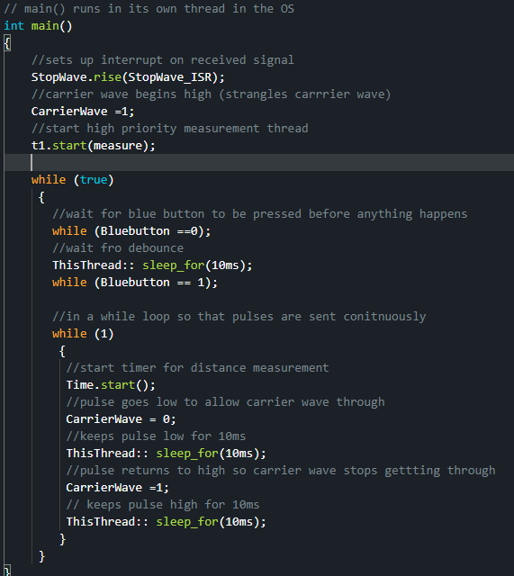

The high priority thread waits for a flag set by an interrupt service routine that fires whenever a high pulse is shown on the GPIO pin that is connected to the rectified received signal.

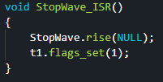

When this flag has been set the measure thread will run, taking the time reading and storing it in a variable. From this measurement it then calculates the distance the carrier wave has travelled and outputs both this and the time it took to the serial monitor before resetting and stopping the timer for the next measurement and sleeping until next distance measurement is received:

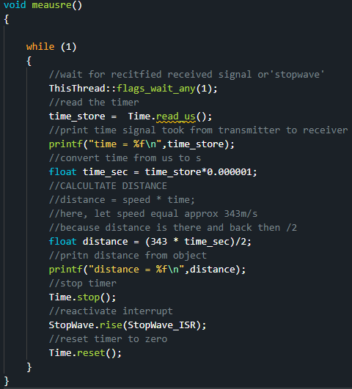

This was the original set-up of the distance measurement component, and so testing of this set-up was begun to see how well/accurately it worked. The 40kHz transducers were the first pair used, and after checking the characteristic channel frequency for these particular transducers by setting them up facing each other at a distance of 10cms apart and scrubbing through different frequencies between 39and 41kHz, it the carrier wave was set to 40.4kHz:

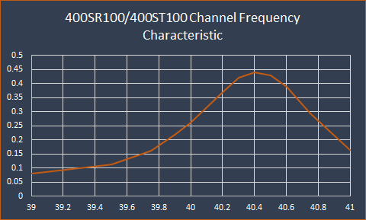

## *EARLY TESTING*

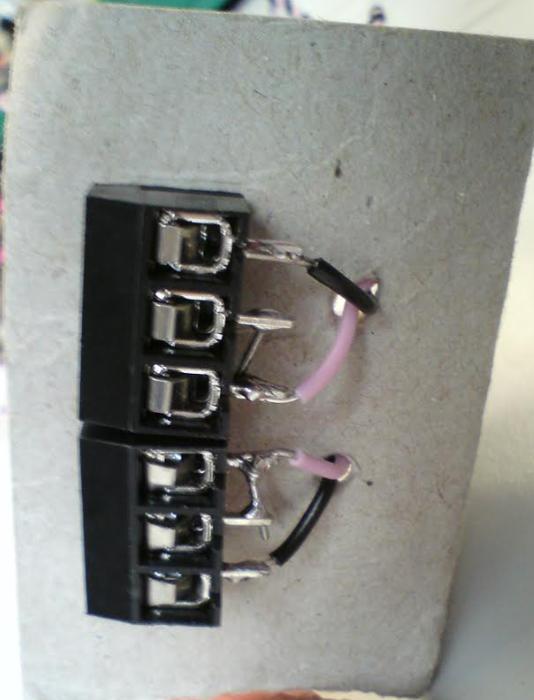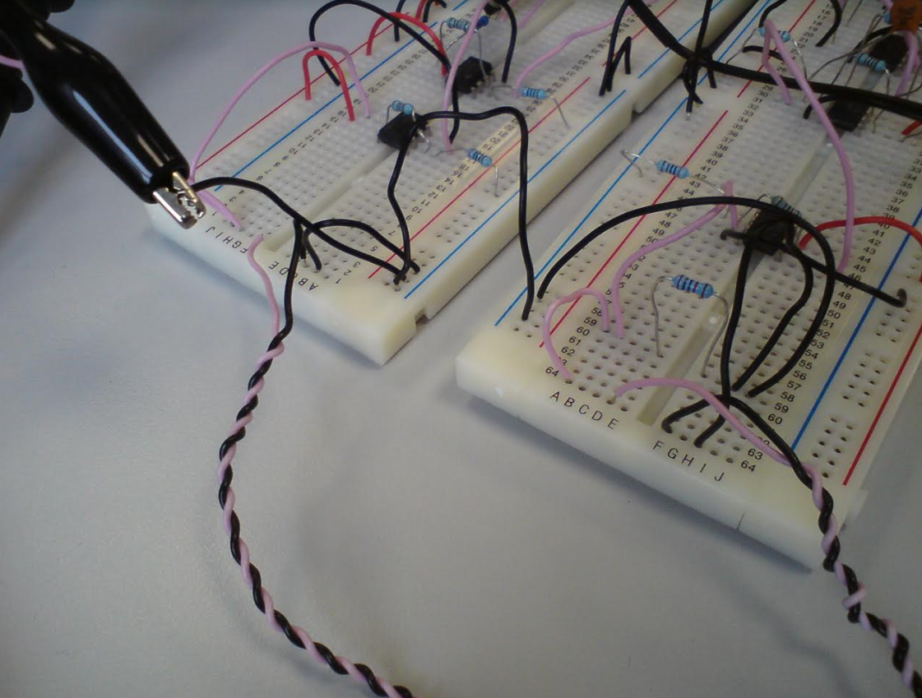The set up for the initial testing was as follows. Using a cardboard as a makeshift mounting surface for the two transducers, hand twisted wires connected the transducers to two testing breadboards, one containing the transmitter circuit and the other containing the receiver circuit as can be seen in figures x and y.

An A4 sheet of cardboard was used as the surface that the ultrasound signal would reflect off to give a distance measurement and was held upright at an angle roughly perpendicular to the table-top surface by a set of clamps. The distance between the end point of the transducer and the cardboard reflector was measured by a tape measure and the distance between the transducers and the cardboard was changed by moving the cardboard closer or further away from the transducers. Although every effort was made to keep the cardboard reflector surface parallel with the transducers and moving only in one plane (i.e. only backwards and forwards but not side to side) as this was done by hand and using only eyes to judge that this was the case, error invariably crept in although it was not felt that this would change the results too much, and was considered minimal certainly for early testing on the distance detector.

The initial testing found that the circuit and code worked in so far as a 40.4kHz sine pulse signal was sent by the transmitter circuit and was received and rectified into a DC on/off pulse by the receiver circuit which was understood by the microcontroller that caused a distance measurement to be displayed on the serial monitor. This can be shown to be working in figure x, where the sent signal portrayed by the yellow probe whilst the rectified received signal is shown by the green probe. The time delay between the two signals can be seen in the bottom right of figure x and highlighted by the red box which shows it to be 1.5ms. Figure Y shows the measurement done by the code and as can be seen this shows the same time delay as the oscilloscope at around 1.5ms (time in code is shown in us) and it also accurately does the calculation to give a distance reading of about 26cm:

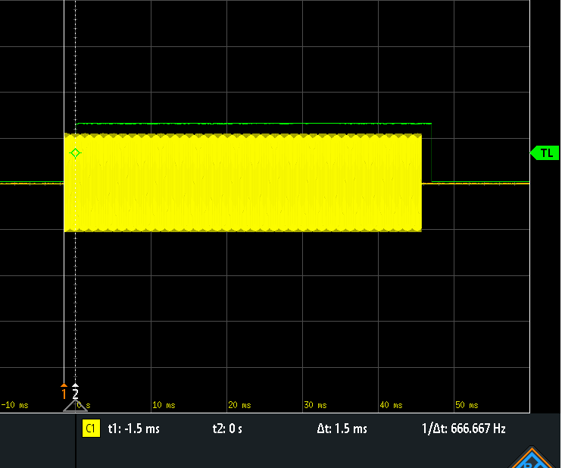

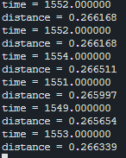

This shows that the theory behind the distance detector unit works in principle, however the actual distance that was being measured between the reflector surface and the transducers was 16cm, which is an error of 10cm which is a very significant difference.

### *Propagation Delay Through Circuit*

Although it was considered unlikely that the actual propagation delay through the circuit was causing such a large error, it was decided to check measure the propagation delay to see how large it was just in case it was larger than expected and since the propagation delay would become more important later in the project as the distance detection unit was attuned to become more and more accurate. In order to achieve this the transducers were removed from the set up and wires we connected directly between the transmitter and receiver circuits and an oscilloscope probe (again shown in yellow) was connected to the start of the carrier wave in the circuit and another one was connected to the output of the receiver circuit (again shown in green) and the distance between the start of the two signals was measured. A screenshot of the results on the oscilloscope is shown in Figure X and again the output to the serial monitor from the code is shown in Figure Y:

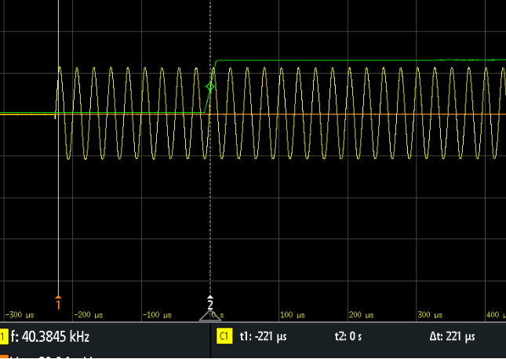

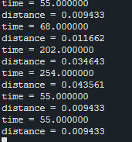

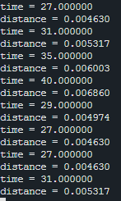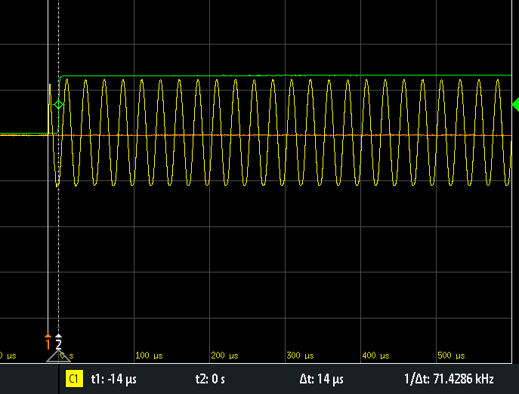As can be seen, the readings of the propagation delay were surprisingly large, oscillating between 55us to around 250us, and captured on the oscilloscope at 221us, which would equate to a maximum of about 4cm error in distance measurement according. Although as this is divided by two in the code as it is measuring to the reflector and back again whereas here the distance is direct and so the actually correlate to an 8cm error. It was though that the op-amps could be a fairly large contributing factor to this propagation since the basic [LM741](https://www.digikey.co.uk/htmldatasheets/production/94208/0/0/1/LM741-Series.pdf) op-amp was used which has a small slew rate of only 0.5us as shown in the datasheet. For this reason it was decided that all the op-amps would be swapped out for [TL081](https://www.digikey.co.uk/htmldatasheets/production/7656/0/0/1/TL081.pdf) op-amps which were also readily available in the labs and had an identical pin-out to the LM741’s only with a considerably higher slew rate of typically 16us. With only this change in place the propagation delay measurement testing was set back up again the same as before, with the wires connecting the transmitter and receiver circuits again. The results are shown in the Figures X and Y, with the yellow probe again showing the start of the carrier signal and the green probe showing the signal at the end of the receiver circuit in Figure X while the time delay shown on the oscilloscope is corroborated by the outputs of the code as shown in Figure Y.

As seen in the figures, the propagation delay has dropped significantly to oscillate much more gently around 30us and shows only around a half a centimetre error in distance measurement by the code and so as explained above correlates to 1cm error in distance since the distance is travelling directly and not bouncing off of anything. Making this change then has amounted to a reduction in distance measurement error of around 7cm which is considerable and would take away most of the 10cm error found in the first test shown in Figure ‘X_LONG_AGO’ and for this reason it was decided to stick with using the TL081 op-amps from now on.

### *Adding Back in Transducers*

Now that the propagation delay has been investigated and corrected to a much more reasonable delay error the 40kHz transducers are put back into the circuit so that the transmitted signal once again has to travel to and from the object whose distance is being measured before it is received and rectified in the receiver circuit. The reflector is placed at the same distance away from the transducers as it was for the initial testing, i.e. at a distance of 16cm and the time between sent and rectified signal was again measured on the oscilloscope as shown in figure X with the yellow probe showing the sent signal at the transmitter and the green signal showing the rectified received signal just before it is attached to the MCU GPIO pin. The measured distance can be seen in Figure Y:

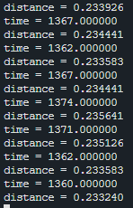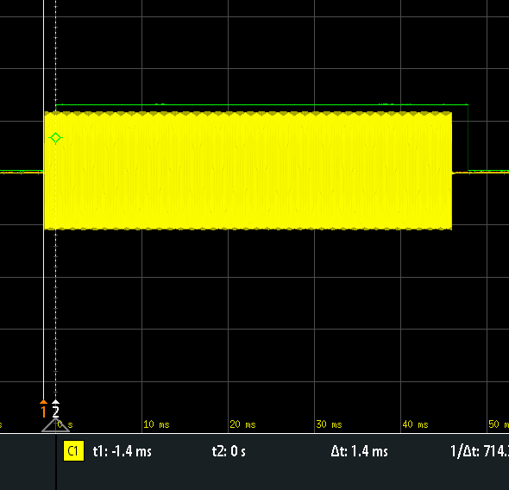Unfortunately, although the measured distance outputted by the code has dropped by roughly 3cm this does not correlate with the expected drop of 7cm after changing the op-amps for superior models which means that the error between actual distance and measured distance is being caused by something else. Moreover, when the reflector object was moved closer or further away from the transducers this did not cause a linear or even understandable change in the distance measured and which lead to the conclusion that the signal sent by the transmitter was not being reflected back to the receiver by the cardboard, or if it was it was also being reflected off of another object as well, thus changing the time the signal took to return to the transducers in a seemingly random way.

In order to test this theory first the 40kHz transducers were switched out and replaced with the 50kHz transducers since these are encased with a shiny black plastic housing that should direct the signal better than the 40 kHz transducers which had no housing. The 50kHz transducers can be seen in Figure X whereas one of the 40kHz transducers is shown in Figure Y:

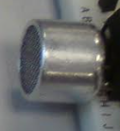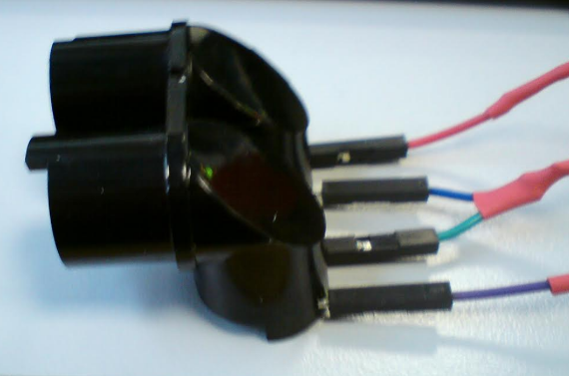

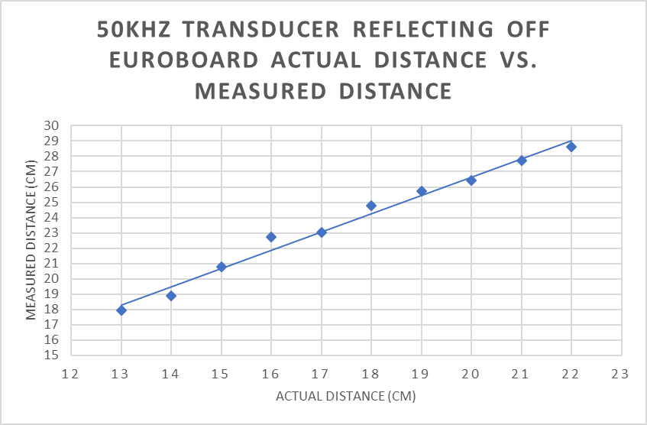Performing the same experiment with the same set-up just with the only differences being the change from 40kHz transducers to 50kHz transducers with a corresponding change in the carrier frequency to 50kHz along with changing the reflector material from cardboard to Euro board as this is more rigid and so less likely to curve and bend, which might interfere with the direction of the signal. A series of measurements taken 1cm apart between 13cm and 23cm were then recorded of the distance measured by the circuit and this is plotted against the actual distance and this graph is shown in Figure X.

As can be seen from the results, there is a far more linear relationship between the actual distance and measured distance, at an error of roughly 5cm. This would seem to suggest that the problems in using the 40kHz transducers was the difficulty in being able to aim them or know what the ultrasound wave was bouncing off since it isn’t visible to the human eye.

Similar housing that encases the 50kHz transducers was thus attempted to be roughly made only using thin cardboard found around the lab but it was difficult to keep it in place and in some cases the designs reflected the sent ultrasound pulse straight back into the receiver as even waving a hand near the face of the transducers didn’t change the measurement reading. It was decided then, that proper housing mimicking almost exactly would be designed properly on the 3D modelling program ‘Autodesk Fusion 360’ which is found on the lab computers and this would then be 3D printed to give a proper casing for the transducers and hopefully better direction to the signal. Until this was 3D printed, however, the 40kHz transducers were set up facing each other so that they would have better directionality and the basic principles of measuring the time it takes for the signal to be received once it has been sent could still be looked into at other frequencies to just 50kHz. Also, if the distance measured had a linear relationship between it and the actual distance when the transducers were facing each other then this would corroborate the theory that the seemingly random readings that the code was giving when the 40kHz transducers were facing in the same direction was due to the signal reflecting off of an object other than the intended reflector.

### *Transducer Measurements When Set Facing Each Other*

Thus, the transducer and receiver were set up facing each other with the resto of the circuit staying the same at an initial distance of 5cm apart. The distance was measured using a tape measure still however this time the distance was measured from the back of the transmitter to the back of the receiver as it was noted that the actual element of the transducer sat at the back of the and still had to travel the length of the casing before as well as the distance between transducers. The set up for the revised distance measurement experiment can be seen pictured in Figure X.

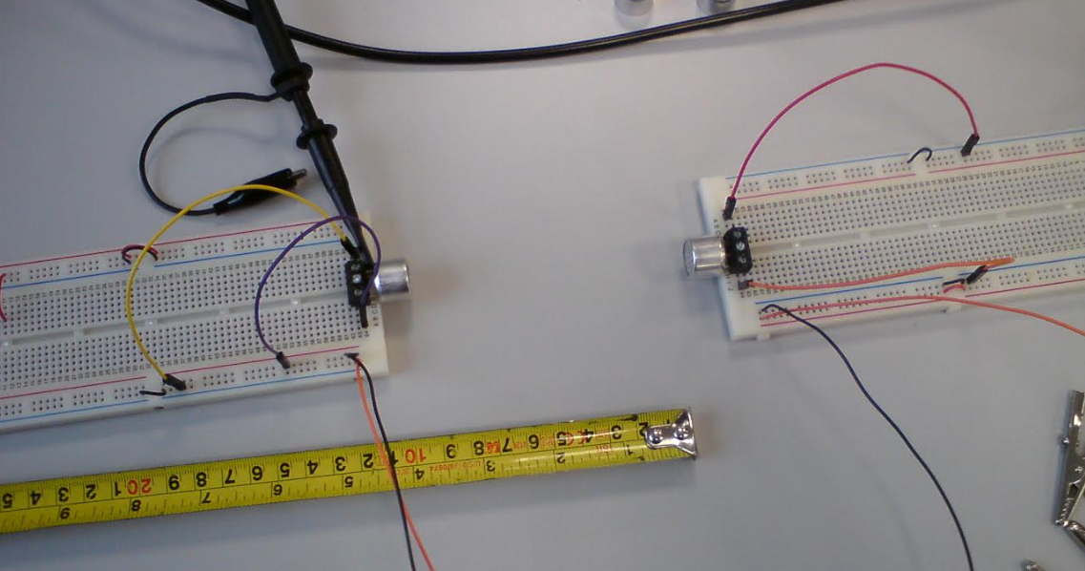

Initially, with this set up that it should be noted that the power of the received signal was much greater than when the transducers facing the same direction than each other and this meant that, with the comparator threshold voltage set to only 1.1V, the circuit was outputting a digital high output constantly as the comparator was now reading amplified noise as signal as well. It was decided that for this experiment that time difference would be read using the oscilloscope only, with the oscilloscope measuring between the start of the transmitted pulse and the rising edge of the rectified pulse before it was passed into the comparator. A reading was taken at 5cm and then the distance Was calculated manually. The distance was increased in steps of 5cm up to a distance of 40cm, taking time delay and working out the measured distance each time. This measured distance was then plotted against the actual distance between the transducers as shown on the graph Figure X:

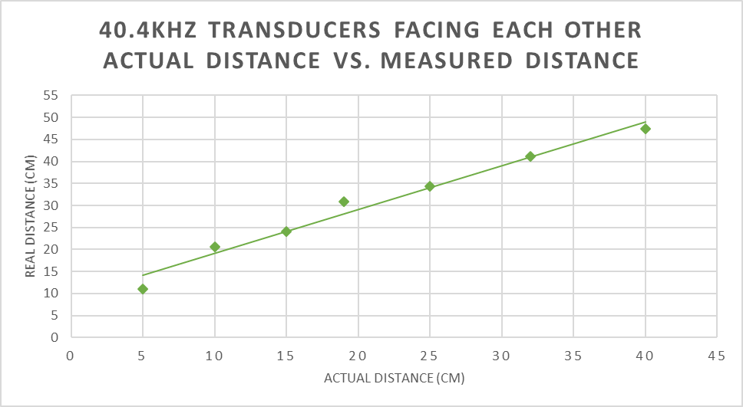

As can be seen here the relationship between the actual distance and the measured distance is now far more linear with the error between actual and measured distance ranging between 5cm and 10cm, which, as mentioned earlier, would suggest that the problems faced when measuring the distance between the transducers and the particular reflector object arose from the direction of the ultrasound wave not being as straight as desired and bouncing off of objects other than the object whose distance was being attempted to be measured.

Having completed this experiment with 40kHz transducers it was noticed that although the relationship was fairly linear between the actual and measured distance, as it had been between the 50kHz transducers, the error in the distance measurement had increased from roughly around 5cm at 50kHz to closer to10cm at 40kHz, which, since sound travels at a constant speed regardless of the frequency (REFERENCE?), was unexpected. It was decided to repeat the experiment done with the 40kHz transducers with the 25kHz transducers as well, i.e. taking the distance measurement with the transducers facing each other rather than facing in the same direction, to see whether it was the change in set-up that had caused the greater distance measurement error, or whether somehow the change in frequency was also changing the size of the error. The results of this were plotted on the same graph as the 40kHz measurements. The 50kHz measurements from the earlier experiment were also added onto the graph so that the trends between the frequencies could more easily be compared to one another.

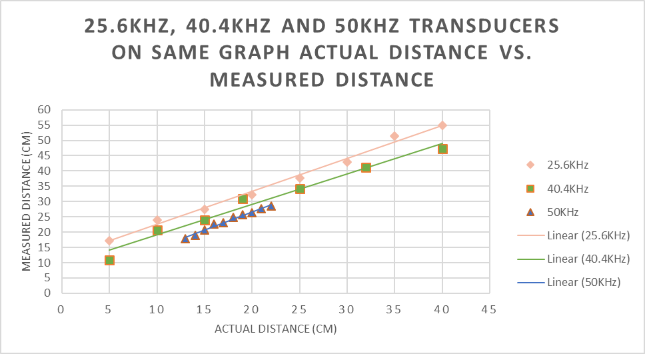

Trendlines were added to the data points to assist analysis though should not be used to draw conclusions. It can be seen, however, that as the frequency is reduced, the error in the distance measurement is increasing and so the frequency was likely having an effect on the accuracy of results.

Here it seems pertinent to add that while this testing was carried out, to see whether other aspects of the wave were having an effect on the accuracy of the distance measurement system the amplitude of the initial carrier signal was changed. Using the 40kHz transducers and keeping them at a constant distance of 10cm away from each other, at 100mVpp the delay was 900us, at 500mVpp, the delay had dropped to 700us and at 1Vpp the delay was lower still at 600us. Although not very in depth, this brief experiment would seem to suggest that the change in amplitude was also changing the accuracy of the distance result which also shouldn’t have been the case since the speed of sound also remains constant regardless of its amplitude.

## *CONCLUSIONS FROM EARLY TESTING*

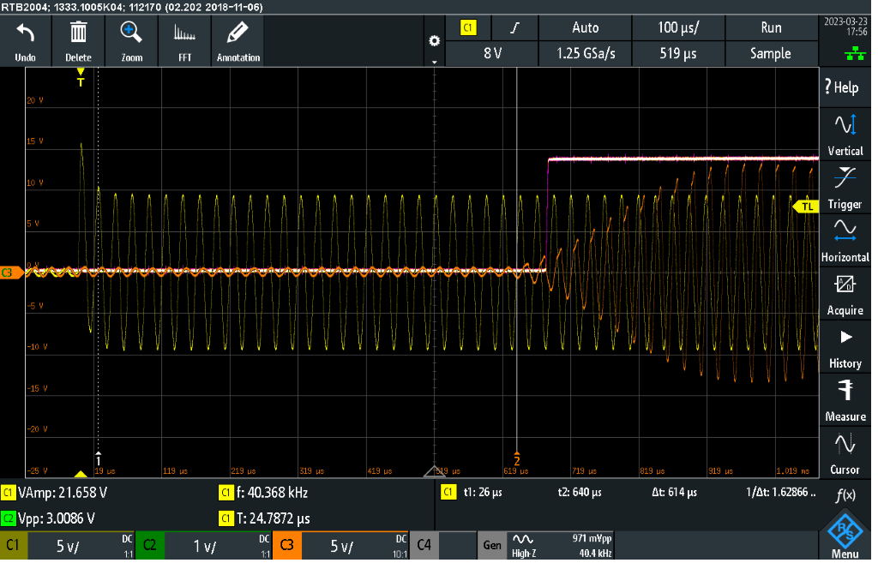The set up for initial testing evidently wasn’t the most precise and in terms of re-testability, there would always be a margin of error and unsureness as to whether the distances and points between transducers were exactly the same but the conditions were kept the same and the set-up was repeatable enough to be able to draw some interesting conclusions about the early design of the circuit. This circuit adds in an error in distance which depends on the input signal as to the severity of the inaccuracy, i.e. its amplitude and frequency. As mentioned above, since the input signal itself will not change the speed it travels through air so long as the temperature is fairly constant, which within the labs it is, and so there must be another reason for this. The oscilloscope is used to zoom into the transmitted and the received signal, along with where the signal goes high to signal to the code to take a time measurement. The yellow scope is used to depict the transmitted signal, the red probe for the received signal, and the white probe to show where the signal goes high:

What becomes clear when zooming into these signals is that there is never a point in time where the transmitted signal is fully zero, rather in its ‘sending’ phase the transmitted signal has an amplitude of 10Vp and in its ‘off’ phase this amplitude has dropped to roughly 500mVp but the signal is still slightly present. This is in turn picked up by the receiving transducer, where there is always some kind of signal being picked up, either very small, or larger. It is also observed that the signal is not received straight away at its full amplitude but rather builds gradually from very smaller oscillations to larger and larger oscillations before it reaches its peak amplitude. This more than likely serves to explain why the error in distance is different depending on the frequency and amplitude since the time measured to give an accurate distance should be between the start of the transmitted signal and when the signal first starts to be detected on the received transducer. This point is where the signal first begins to grow in amplitude, not where it reaches its top amplitude, however the received signal will only cause the comparator to output a ‘high’ pulse once the amplified received signal has reached above 1.1V which in this screenshot only happens a few oscillations after the received signal begins to grow. Since at a higher frequency there are more oscillations of the signal in the same time, these oscillations are closer together and thus one or two oscillations of the signal at a lower frequency will occur over a longer time range than at a higher frequency. Thus, the amplitude of the signal will increase faster at a higher frequency, causing the time to be read slightly sooner than at a lower frequency. Similarly, the higher the initial amplitude of the transmitted signal, the closer the signal will be to the threshold when it is received and so the amplitude will rise above this threshold sooner than if the received signal’s amplitude was smaller where there is a greater difference between the amplitude and threshold voltage.

Ideally, then, there should be no signal at the receiver, a constant 0v, until the transmitted signal is received at which point the received signal should shoot immediately to the peak amplitude of the received signal. Although neither of these extremes will be possible to reach in practice since the receiver will always pick up some form of noise which when amplified will also be amplified into a larger noisy signal, and the transducers used aren’t precise enough to pick up all of the transmitted signal straight away there are ways to minimise the signal received by the receiver when the transmitted signal is in its ‘off’ phase and to reach the peak amplified of the received signal sooner.

## *CHANGES TO THE TRANSMITTER CIRCUIT*

### *Changing the BJT circuit*

First, stopping there still being a signal when the transmitted signal should be in its ‘off’ phase will be looked into. When probing the BJT currently that was initially in use, the [BC547B](https://docs.rs-online.com/7994/0900766b813843c4.pdf), it was noted that even when there was a high voltage on the base, the signal was not fully being stopped from getting through. The bjt being used was causing clipping and distortion on the negative part of the signal, if the base resistor value was too small, but if the resistor value was too large then it was allowing signal through even when there was a high voltage on the base. Figure X shows the waveform of the transmitted signal in yellow and the resulting received waveform is shown in red when there is only 2Ω on the base of the bjt and distortions to the negative part of the sinusoid can clearly be seen. On the other hand, in Figure Y, the transmitted signal is shown in yellow and the received signal is in red when there is 50Ω on the base. The ‘on’ and ‘off’ phases of the bjt is overlapped and it can be seen that although the waveform is less distorted when in the ‘on’ phase, in the ‘off’ phase a sizeable amount of signal is still being allowed through.

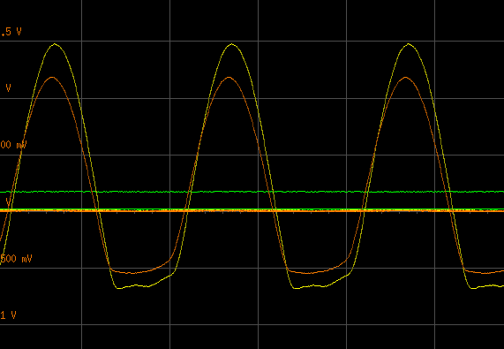

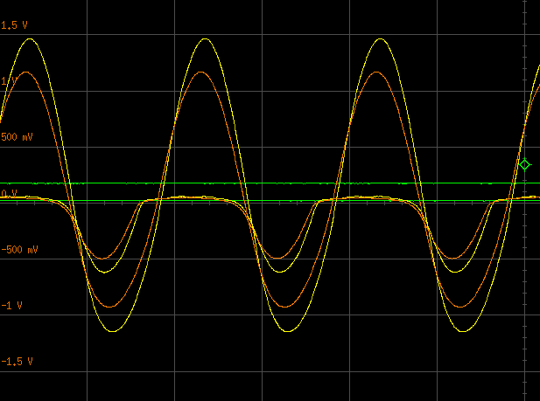It was decided to try and change the bjt to a logic MOSFET which can have better switching abilities unfortunately this idea was quickly discarded as the MOSFET greatly reduced the signal strength by a factor of 10 and the reason for the could not be figured out why. Instead another bjt, the [ZTX651](https://docs.rs-online.com/c35c/0900766b81383ebc.pdf) was used as it showed superior in not letting the signal through when in its ‘off’ phase during testing. However, distortions of the negative part of the signal were still present and so it was decided that the generated carrier signal would have a DC offset so that it would have the same amplitude of 1Vpp but between the range 0-1V. this would then be amplified once and then go through the bjt. The DC offset would then be taken away using a capacitor in a high pass filter set up. The high pass filter was set so that the cut-off frequency well below the lowest frequency being tested, i.e. well below 25kHz. This signal is then amplified again before being transmitted through the channel. To check how this would behave in the circuit and whether it would give the desired effect, the complete transmission circuit would simulated using ‘Proteus 8’ with these changes and can be seen in Figure X:

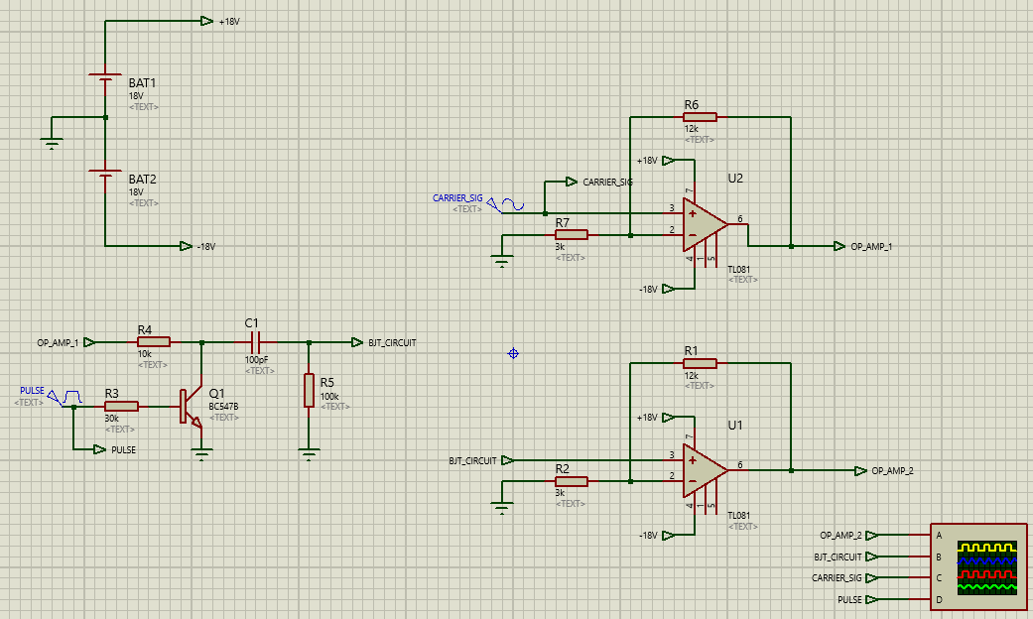

Figure Y shows the output of the simulated circuit, the yellow line shows the overall output of the circuit, the blue line shows the output of the bjt circuit after the DC offset has been removed, the green line shows the voltage on the base of the bjt, and the pink line show the original generated signal before it has been amplified or gone through the bjt.:

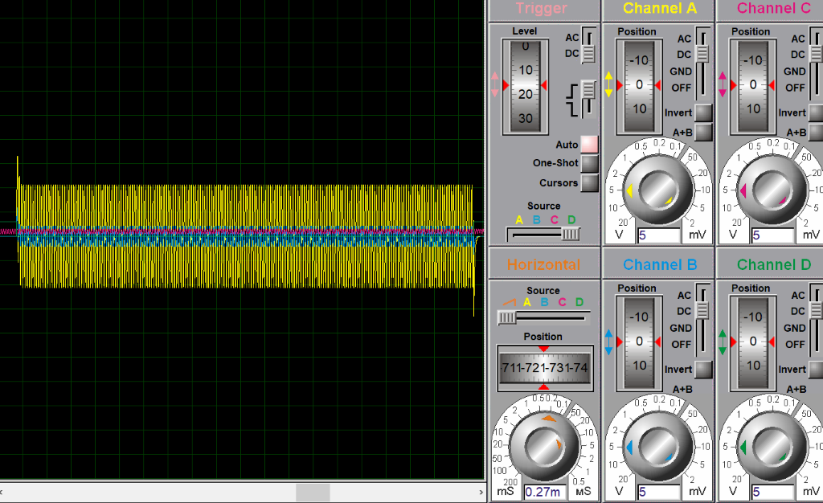

A zoomed in version of Figure Y can be seen in Figure Z:

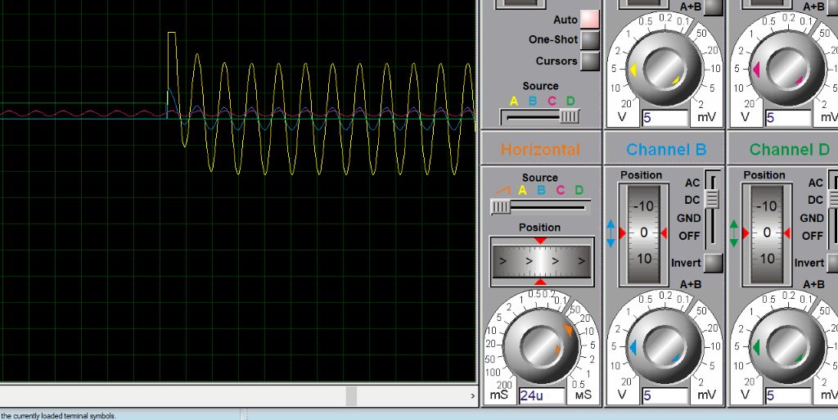

It can be seen from this that the simulated results show a clean sinewave with these parts when the signal is allowed through the bjt and when the signal is restricted it can be seen that it doesn’t get through as it was previously. It thus decided then to keep this change as it caused as much smaller voltage ripple on the transmitted signal wasn’t intended to be present. Because of this change making the restricted signal much smaller, it was decided to increase the original generated signal from 1Vpp to 2Vpp, as it was thought this would increase the size of the oscillations on the received signal when they first arrived as well, bringing their amplitude closer to the threshold voltage to give a signal high pulse sooner.

### *Adding Inductance*

Secondly, it was attempted to increase the immediate response of the receiving transducer so that it would increase in amplitude quicker to its full amplitude. It was suggested that the introduction of an inductor in series with the transmitting transducer and an inductor in parallel between the signal pin and ground of the receiving transducer could help this. It was explained that at a frequency of 40kHz an inductor value of 6.8mH should be used to get this result. The transmitting and receiving circuits were set up in this way and a signal was sent between the 40kHz transducers which were set up to face each other at a distance of roughly 20cm apart. A screenshot of the signal with the inductors present is shown in Figure X, with the time between the start of transmission (shown in yellow) and the first oscillation of the received signal above the threshold (shown in white) measured:

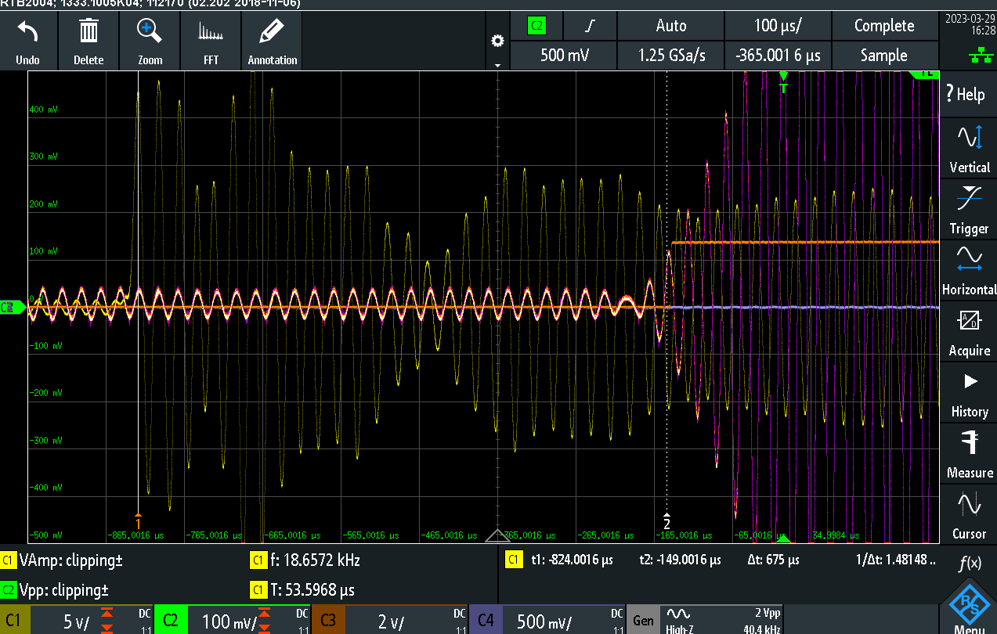This can be contrasted with the same 40kHz transducers at the same distance but without the inductors as seen in Figure Y, again the time between the start of transmission (shown in yellow) and the first oscillation of the received signal above the threshold (shown in white) is measured:

As can be seen when comparing the two waveforms, although with the inductors present the received signal is growing at a faster pace, the inductors give an initial distortion to the wave, causing an initial drop in amplitude before it grows, and this probably accounts for the fact that the distance measured in both cases is very similar (only 4us difference). Other set-ups were tried with the inductors in series only or in parallel, but this still didn’t seem to positively affect the distance measured. Having tried this it was decided not to add the inductors as they didn’t improve the circuit and caused extra distortions in the sent and received signal which could add error in the measurements at other points.

## *SECOND TESTING OF CIRCUIT*

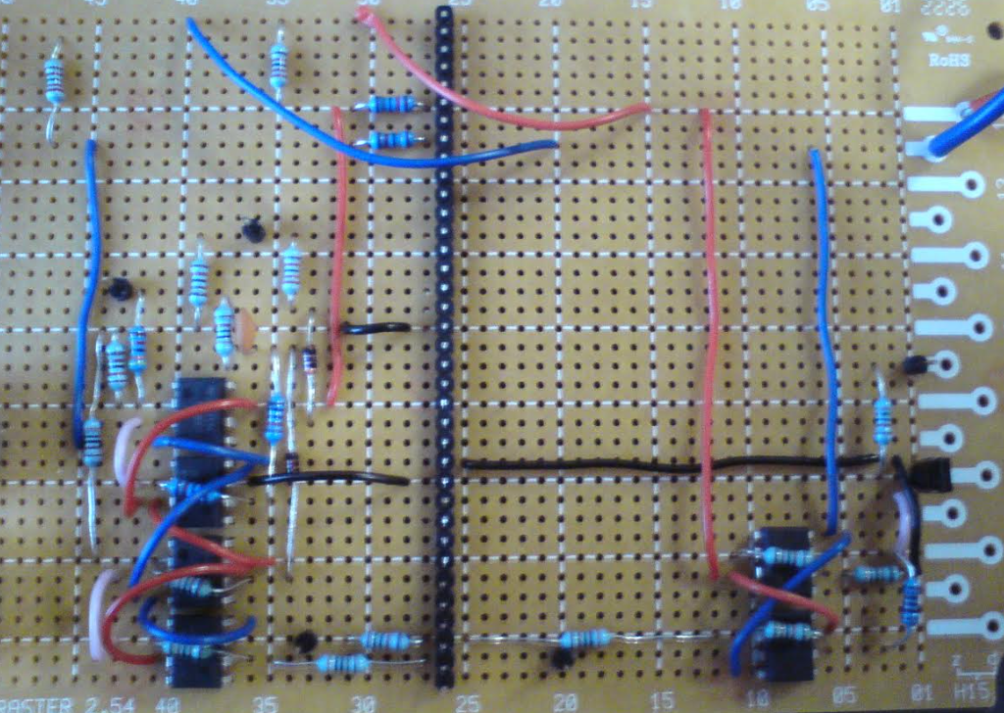Having decided on these changes to the circuit it was decided to solder the circuits onto a board so that they couldn’t move and the distance between the wires of the circuit could be as close as possible. The transmitting and receiving circuits were soldered onto the same board with a common ground rail dividing the two circuits. A picture of the board can be seen in Figure X:

The transducers were mounted on a separate testing breadboard and the wires were trailed back to the circuit. The circuit was mounted on one side of some wood board and the transducer board was mounted on the other side of the same board. This was then attached vertically to the end of a moving platform rig. The rigs platform can move up to 900mm away from the board, and a white reflector surface was attached vertically to the centre of the moving platform. The distance along the moving platform rig can be remotely controlled from the computer using an interface. Figure X shows a close up of the board holding the circuit and transducers whilst figure Y shows a picture of the new set-up for testing.

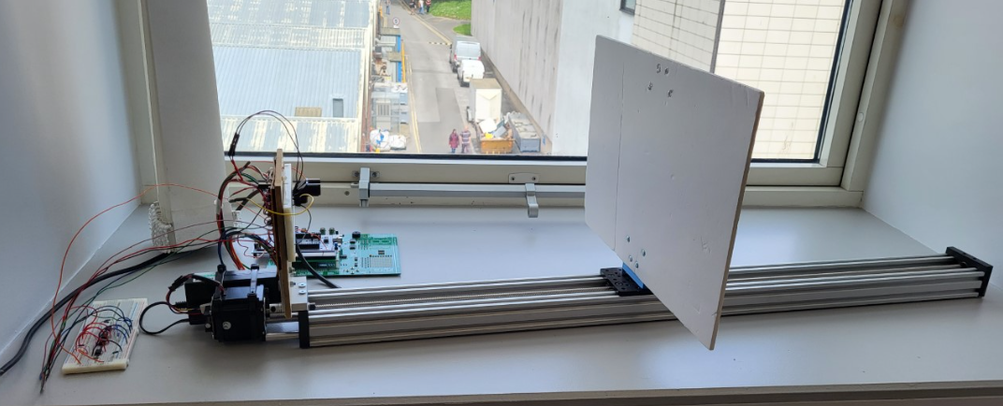

The use of the moving platform rail means that testing can be far more accurate since once the initial distance between the transducers and the board on the platform has been determined then using the interface shown in Figure Z the distance between the board and transducers can be changed in a precise and constant step size.

This also means that testing can be repeated under the same conditions meaning in more accurate comparison between changes in the circuit as one can be sure that there are no other changed factors accounting for differences in results. Since this error in distance has not been able to have got rid of totally as if the threshold is reduced any further then it will pick up the amplified noise as received signal as well but at its current level there is a delay between the start of the received signal and the point it is registered as a change from no signal to signal, it is decided to measure the discrepancy between the time it should take at a certain distance from the board and the measured time it took for the signal to be sent and picked up by the circuit over a series of distances. It was intended that the average discrepancy between the actual time and the theoretical time would then be calculated, and this would be subtracted in the code from the measured time to give a more accurate output of the distance. The distance that the board started from the transducers was 5cm and then data was taken in 1cm steps up from this point. It was decided to start with the 50kHz transducers as the housing for the other transducers to aid with the direction of the signal hadn’t yet been fabricated. It was also decided to add averaging into the code to give a steadier result for the measured time by taking 100 samples and taking the mean of the sampled time delay as the time used in the distance = speed *time calculation. The change in the code for this can be seen in figure X.

It should be noted here that although this averaging technique can help to increase the accuracy of the distance measurement when the object being measured is stationary, when this is used on moving objects, the averaging will add error and will have to be removed. The time error between the actual time the code measured and the theoretical time is plotted against the distance between the detection unit and the reflector to determine whether there were many anomalies from a constant error:

What became apparent, however, after the distance error had been plotted, was that this distance error was not as linear as first believed, but was rather similar over a certain distance range and then would vary before becoming linear again for another distance range. This meant that simply removing a constant us delay would only increase accuracy for a certain distance range and this was undesirable.

It was hypothesised that the change in distance error could be explained by looking at the time it took to reach the threshold before the received signal was registered. The further away the object which is being measured is from the unit, the weaker the received signal becomes. This would mean that the received signal initial amplitude would be smaller at further distances and so have a greater voltage difference to get to before it gets higher than the threshold meaning more oscillations, and greater time delay the farther the object. In order to fix this, two ideas were raised; one would be to vary the threshold reference voltage, making it a ratio of the received signal, and the other idea was to use a technique called Adaptive Gain Control to increase and decrease the amplification of the received signal depending on its initial amplitude, i.e. If the received signal had a small amplitude it would be amplified more than if its initial amplitude was relatively large, this would give a more constant signal size for the threshold to be compared against. It was decided to attempt the variable threshold voltage technique first as this was easier to implement than adaptive gain control and another part had to be ordered to try adaptive control but not for variable threshold and so could be worked on whilst waiting for the part.

### *Variable Threshold Voltage*

The rectified received signal is used in order to get a variable threshold voltage, by being a fraction of this received signal. To decide on the fraction of the peak voltage where the received signal starts to rise the signal is investigated at varying distances from the detection unit, measuring the voltage at the start of the signal and the voltage when the signal has reached its peak:

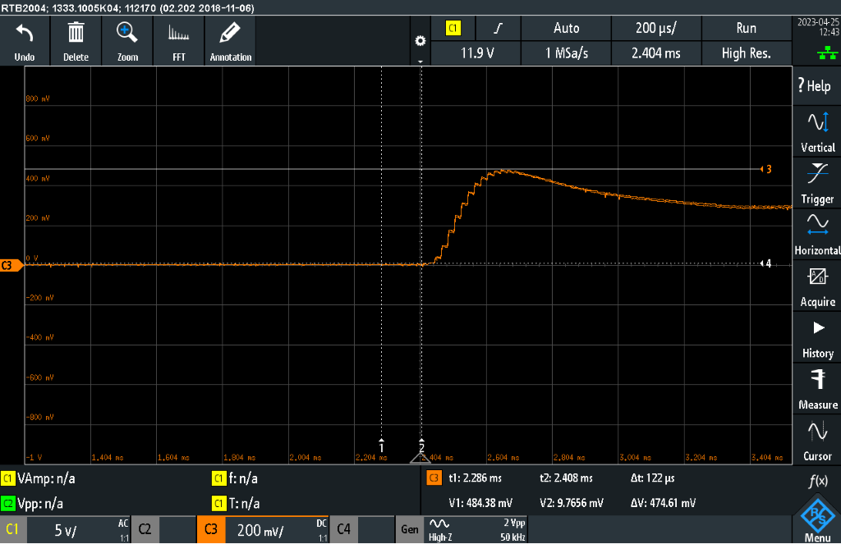This Figure depicts the voltage rectified received voltage at 38cm away from the detection unit. It can be seen that the amplified peak voltage has already dropped to just under 500mV and so shouldn’t have been picked up as a pulse any way, and when it starts to rise it begins at about 9mV which is roughly 1/50th of the peak voltage. Figure X depicts the rectified received voltage now at a distance of 78cm away from the detection unit: